MAJOR PROJECT-1

CREATION OF THREE TIER APPLICATION USING TERRAFORM

CREATE AN INSTANCE AND INSTALL TERRAFORM





STEP1: VPC CREATION





STEP2:SUBNET CREATION





STEP3:IGW CREATION





STEP4:ROUTE TABLE CREATION

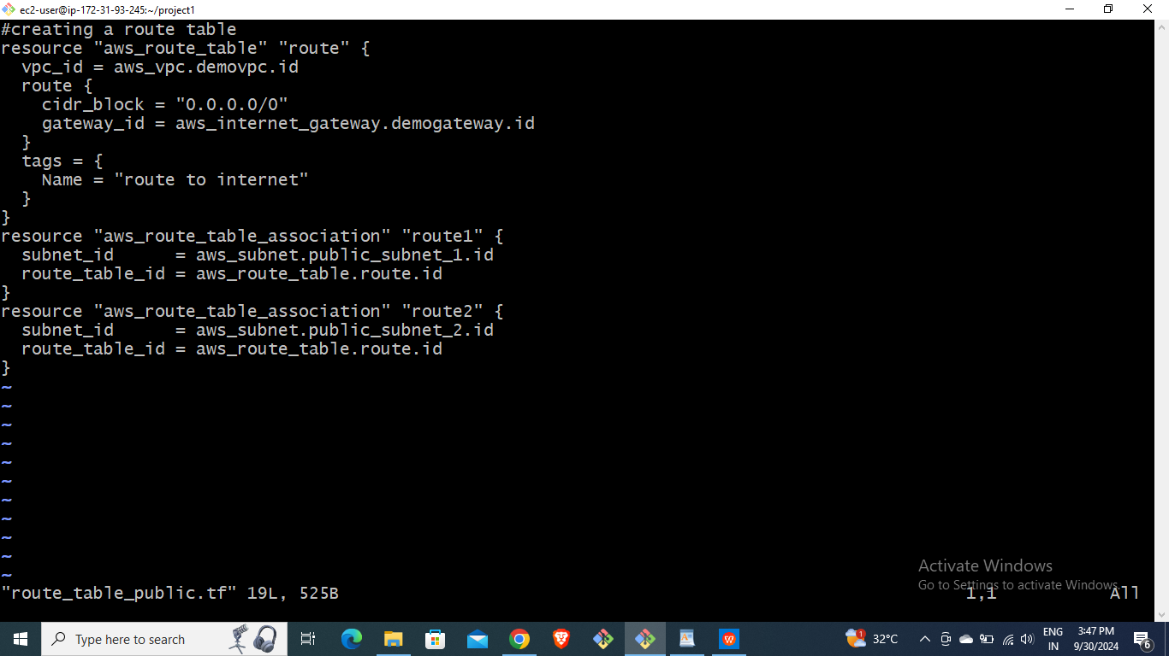

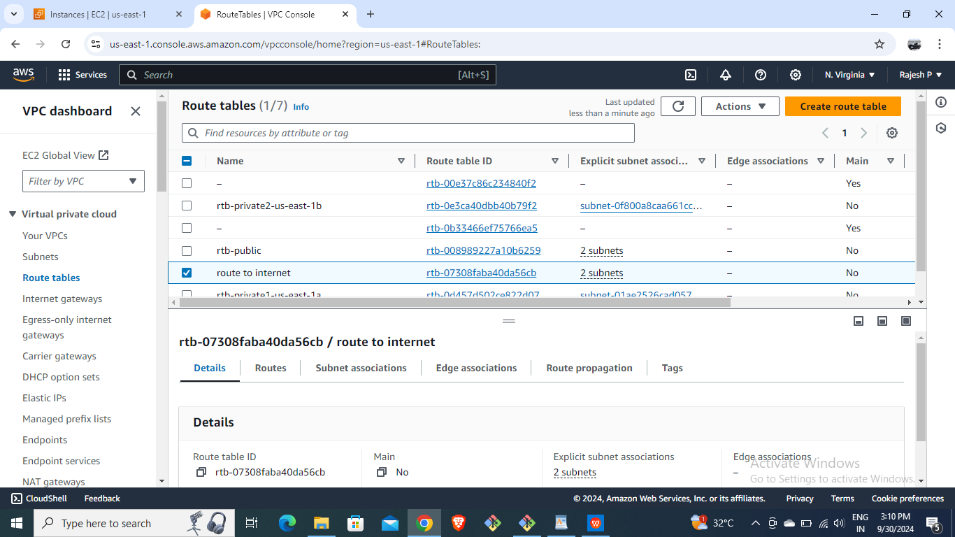

STEP5:CREATION OF TWO EC2 INSTANCES







STEP6:CREATION OF SECURITY GROUPS





STEP7:CREATION OF LOAD BALANCER

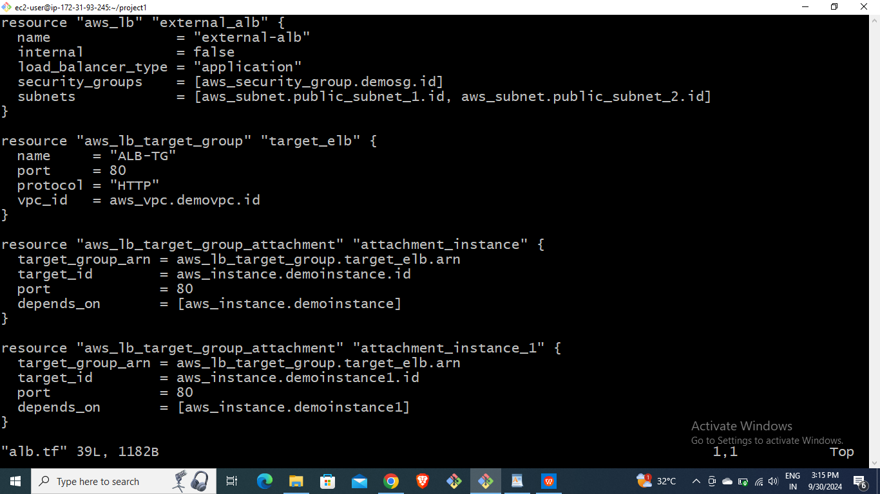

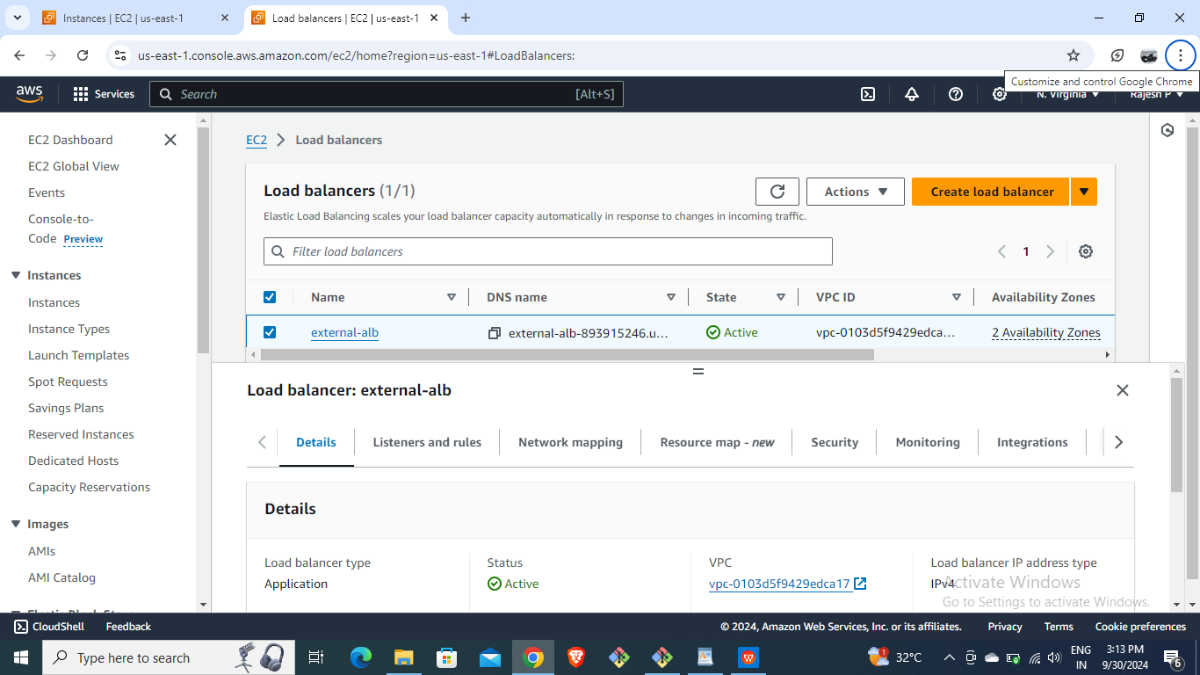

STEP8:CREATION IF AUTO SCALING GROUPS





STEP9:CREATION OF RDS.





STEP10:FILE FOR OUTPUT



STEP11:BROWSE THE URL OF LB AND IT SHOWS LOAD IS BALANCING B/W TWO INSTANCES.



